UNIVERSITY OF WAH (UOW)
DEPARTMENT OF COMPUTER SCIENCE



BSCS 3RD B

REG #: UW-24-CS-BS-088

SUBMITTED BY: SAADI SAFDAR

SUBMITTED TO: SIR. HASSAN SHAFAQAT

COURSE TITLE: COMPUTER NETWORKS

COURSE CODE: CS – 241 L

LAB REPORT # 5

CISCO PACKET TRACER

- Cisco Packet Tracer is launched
- 4 Switches are added
- 5 PCs and 2 Laptops are added
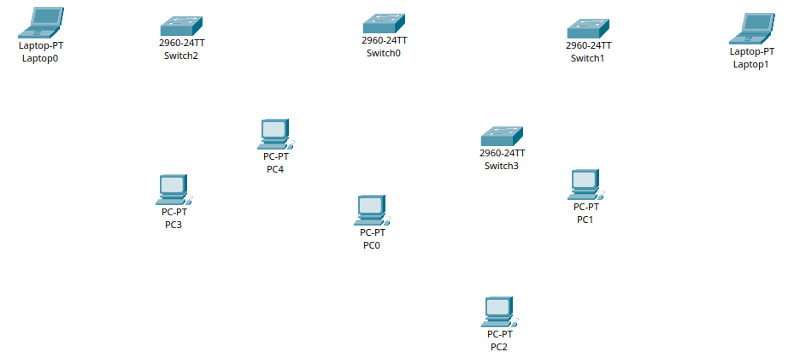
- Every End Device(PCs & Laptops) is connected to Network Device(Switch) by Connection: Copper Straight-Through by FastEthernet
- Every End Device(Switches) are connected to each other by Connection: Copper-CrossWire
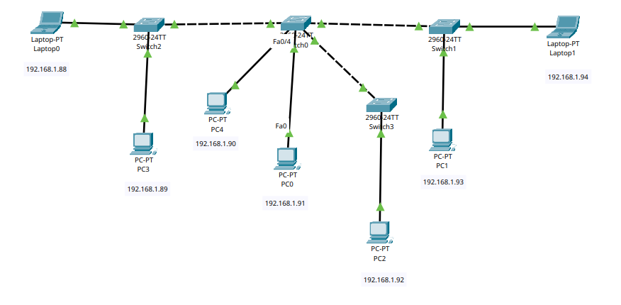

- IP Configuration are setted for End Devices by using reg no as IP address

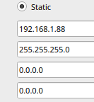
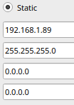
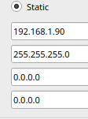
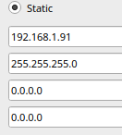
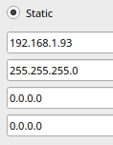
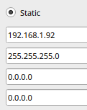
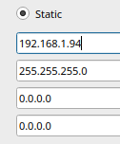

- Here are all the successful connections between End Devices by checking the connectivity using the ping command for all end devices

